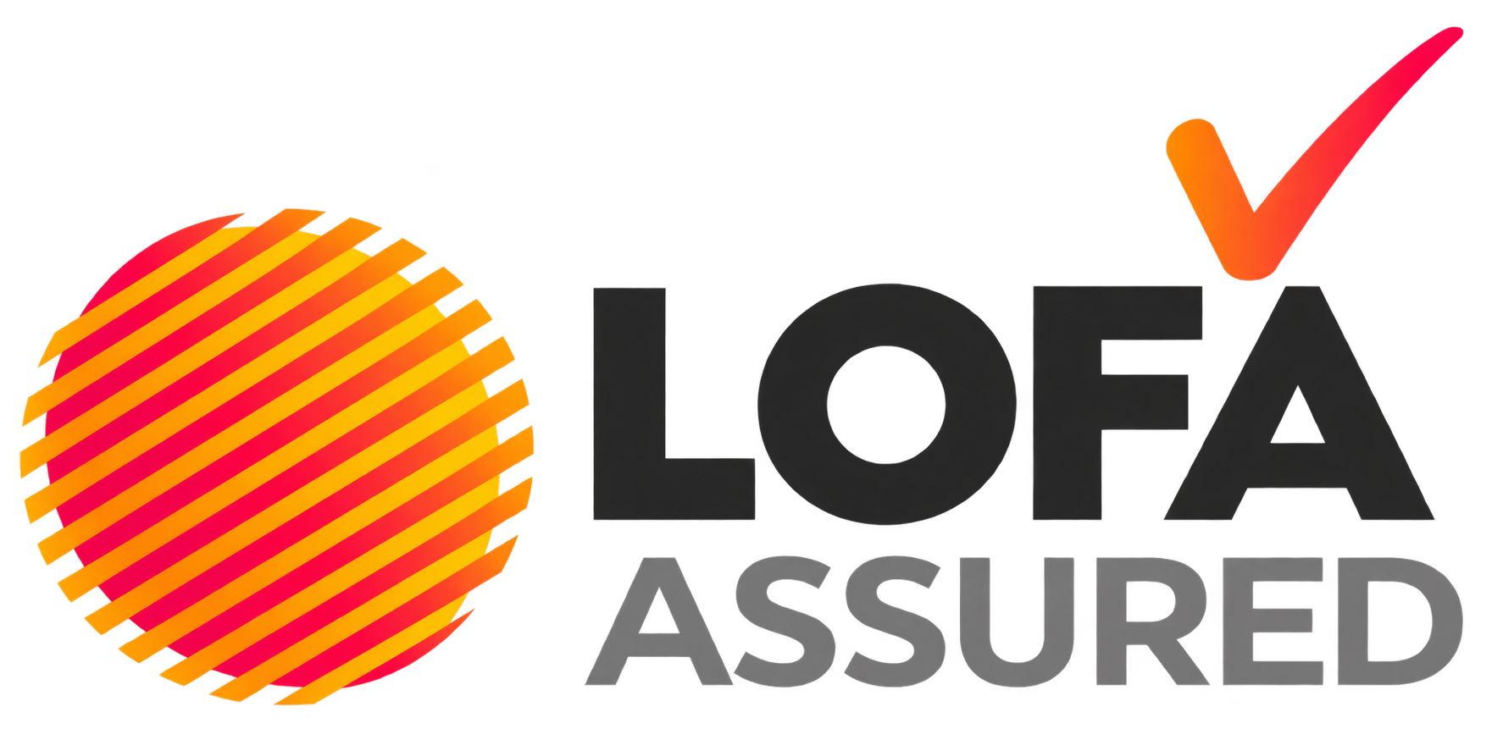

A consumer guide to garden-furniture cushions
and fire safety
For consumers in Great Britain: England, Scotland and Wales
Updated August 2026
Important: This guide provides general consumer information. It is not legal advice. Product requirements can depend on the type of furniture, how it is supplied and where it is sold. Separate regulatory assessment is required for Northern Ireland.

Outdoor living should be enjoyable and safe. When buying garden furniture with cushions or other upholstered parts, you may see the LOFA Assured mark. This guide explains what that means, why fire safety matters and what to look for when choosing furniture.

What is LOFA Assured?
LOFA Assured is an initiative of the Leisure & Outdoor Furniture Association (LOFA). It is designed to help consumers identify garden-furniture cushions supplied by LOFA members that meet current UK fire-safety legal requirements.
LOFA describes LOFA Assured as a commitment to quality and safe manufacturing. Members are independently audited and verified against the initiative’s regulatory and safety benchmarks.
Look for the LOFA Assured swing tag on garden-furniture cushions. It is an additional sign that the supplying LOFA member has met their legal obligations regarding fire safety. The product is supplied by a LOFA Assured member.
- The member is expected to work to applicable fire-safety and legislative requirements for relevant cushions and upholstered garden furniture.
- The member has been independently audited as part of the LOFA Assured initiative.
- The product should be supported by the supplier’s testing, traceability and compliance processes.

A swing tag/label is not a substitute for safe use, and care instructions or the permanent label on the product. Keep both the furniture and its labels in good condition.

Why rules cover garden furniture
In Great Britain, the Furniture and Furnishings (Fire) (Safety) Regulations 1988 apply to many types of domestic upholstered furniture. This can include garden and outdoor furniture that is suitable for use in a home or conservatory.
The rules are intended to reduce the risk that upholstered furniture will ignite too easily or allow a fire to spread rapidly. For relevant products, businesses must ensure that:
- Filling materials meet specified ignition-resistance requirements.
- The combination of the cover and filling is resistant to a smouldering cigarette.
- Visible covers are resistant to a small open-flame source, subject to limited regulated exceptions.
- The product carries the required permanent flammability label.

The legal responsibility for meeting these requirements rests with businesses in the supply chain, including manufacturers and importers. Retailers must also take steps to ensure the upholstered products they sell are safe and correctly labelled.

What should I look for?
1. Look for the LOFA Assured swing tag when buying from a LOFA Assured member.
2. Check for a permanent label attached to relevant upholstered furniture or cushions. It is often sewn into a cushion or placed alongside a care label.
3. Ask the retailer if you are unsure. They should be able to explain who supplied the product and help with questions about labels or care information.
4. Keep labels attached. They help identify the product and provide useful information if there is a safety query, repair, resale or recall.
5. Follow care instructions. Keep cushions dry and clean, and store them as recommended by the manufacturer when not in use.
6. Keep cushions away from heat and flames. Do not use them near barbecues, fire pits, patio heaters, chimineas, cigarettes, candles or other ignition sources.

Permanent labels and swing tags
A permanent label is the legal compliance label attached securely to an item of relevant upholstered furniture. It is designed to remain with the product and assists businesses and Trading Standards officers with product identification and compliance checks.
A LOFA Assured swing tag/label is a consumer-facing mark connected with the LOFA Assured initiative. It helps you recognise cushions supplied through a LOFA Assured member’s compliance and audit framework.
Label or tag | What it is for
Permanent flammability label | Required on many relevant upholstered products; provides product and fire-safety information.
LOFA Assured swing tag/label | Identifies garden-furniture cushions supplied by a LOFA Assured member.
Care label | Explains care, cleaning and storage instructions; it may be combined with a permanent flammability label.

Since 30 October 2025, businesses have no longer been required to attach a separate display label to new upholstered products. You may still see older display-label designs on legacy stock or in older guidance, but their absence alone does not mean that a new product is non-compliant.

Safe use and care
Fire-safety compliance reduces risk; it does not make upholstered furniture fireproof. Use garden furniture and cushions sensibly:
- Keep cushions well away from BBQ’s, fire pits, naked flames, sparks, cigarettes and heat sources.
- Do not place cushions beside a barbecue or fire pit, even when it is cooling down.
- Bring cushions indoors or store them in a dry, ventilated place when not in use, following the manufacturer’s instructions.
- Do not use damaged, scorched or heavily soiled cushions near ignition sources
- Do not alter a cushion’s cover, filling or fire barrier unless a competent repairer can confirm the repair is appropriate.
- Keep packaging, order details and product identification information in case you need product support or receive a safety notice.

Buying second-hand furniture
If you buy upholstered furniture from a business, charity or second-hand retailer, check that any relevant upholstered item still has its permanent flammability label. Businesses should not supply relevant second-hand upholstered furniture without that label.
Private sales between individuals are treated differently, but you should still take care. If a product has no permanent label, is damaged, has been re-covered, has unknown filling materials or shows signs of heat damage, ask questions before buying and consider whether it is suitable for use.

Questions to ask a retailer
- Is this product supplied by a LOFA Assured member?
- Does this cushion or furniture item have its permanent flammability label?
- How should the cushions be stored and cared for?
- Is there a manufacturer’s warranty or product registration?
- Is this product intended for outdoor use only, or is it also suitable for use in a home or conservatory?

Need more help?
For general information about LOFA Assured, visit: https://lofa.co.uk/about/lofa-assured/
For a concern about a particular product, contact the retailer or manufacturer first and keep your proof of purchase, product name and any label or batch information. If you believe a product may be unsafe, you can also seek advice from your local Trading Standards service.
LOFA Assured is an initiative of the Leisure & Outdoor Furniture Association. This consumer guide reflects the Great Britain regulatory position described in the Furniture and Furnishings (Fire) (Safety) Regulations 1988, as amended, including the 2025 removal of the display-label requirement. Review this guide if legislation or official guidance changes.

